Product: | 28-944/127 | 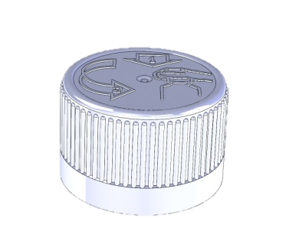
Article number: | Please contact our sales department.
Product Description: | 28mm child resistant closure with ring seal adapted for PCO1810-thread.
Technical specifications
Drawings: | Product drawing: 12210  Neck drawing: -
Sealing: | Ring seal
Plastic resin: | Cover: PPH  Closure: POM
Master batch: | Please contact our sales department.
Recommended capping torque: | 1,8-2,0Nm
Storage durability: | 1 year, keep room temperatured in tightly sealed cardboard boxes.
Certificate | ZERT 06771770414-8317  The package can only be designated as child resistant and suitable for adults if certified package are used according to ISO 8317.
Quality Control
Standards and norms | Sampling procedure: SS 020130-ISO2859 normal 1  Defect classes according to KP-002
Delivery
Packaging | 2.500 pcs packed in plastic bag, packed in cardboard boxes 82dm³. Labels on the boxes. 16 boxes on each pallet with stretch film wrapped around.
Traceability | Marking for traceability contains EVP article number, customer article number, production order number, pieces per carton, EVP order number customer order number and date and signature.

